Week 11
Creating grafana
gcloud container clusters list
gcloud container clusters create my-cluster --zone us-central1-a
gcloud container clusters get-credentials my-cluster --zone us-central1-a
kubectl get nodes
kubectl create namespace monitoring
kubectl get ns
helm repo add prometheus-community https://prometheus-community.github.io/helm-charts
helm repo update
helm install kube-prometheus-stack prometheus-community/kube-prometheus-stack -n monitoring --create-namespace
kubectl get secrets -n monitoring
kubectl get secret kube-prometheus-stack-grafana -n monitoring -o jsonpath="{.data.admin-password}" | base64 --decode ; echo
Access Grafana and port forwarding
kubectl port-forward svc/kube-prometheus-stack-grafana -n monitoring 3001:80
Grafana Credentials:-
user name: admin
Password: prom-operator
week 12
Creating Prometheus
gcloud container clusters list
gcloud container clusters create my-cluster --zone us-central1-a
gcloud container clusters get-credentials my-cluster --zone us-central1-a
kubectl get nodes
kubectl create namespace monitoring
kubectl get ns
helm repo add prometheus-community https://prometheus-community.github.io/helm-charts
helm repo update
helm install kube-prometheus-stack prometheus-community/kube-prometheus-stack -n monitoring --create-namespace
kubectl get secrets -n monitoring
kubectl get secret kube-prometheus-stack-grafana -n monitoring -o jsonpath="{.data.admin-password}" | base64 --decode ; echo
kubectl get pods -n monitoring
kubectl get svc -n monitoring
Access prometheus and port forwarding
kubectl port-forward svc/kube-prometheus-stack-prometheus 9090:9090 -n monitoring

week 9
cluster creation:-
gcloud container clusters list
gcloud container clusters create my-cluster --zone us-central1-a
gcloud container clusters get-credentials my-cluster --zone us-central1-a
kubectl get nodes

Create the pods

kubectl run --image tomcat webserver
To get the list of pods along with ip address and which node the pod is running

kubectl get pods -o wide
Create pd-df1.yaml

Vim pd-df1.yaml

apiVersion: v1
kind: Pod
metadata:
name: jenkins-pod
spec:
containers:
- name: myjenkins
image: jenkins/jenkins
ports:
- containerPort: 8080
hostPort: 8080
for accessing the application u need to open the port

How to open the port

gcloud compute firewall-rules create rule2 --allow tcp:8080
kubectl create -f pd-df1.yaml

kubectl get pods -o wide
kubectl get nodes -o wide

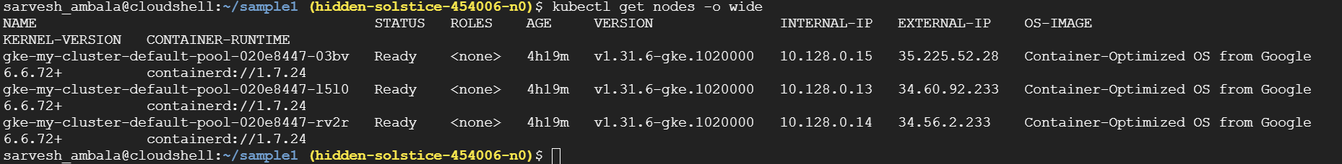

How can we access the pod

Take the external ip add the port no 8080

Open the browser paste ipaddress:8080

Now u can able to see the Jenkins

